**Wire-Frame Design**

Flight Fare Prediction

|  |  |
| --- | --- |
| Written By | Adil Anwar |
| Document Version | 1.2 |
| Last Revised Date | 02-10-2022 |

**Document Change Control Record:**

|  |  |  |  |
| --- | --- | --- | --- |
| **Version** | **Date** | **Author** | **Comments** |
| 1.0 |  | Adil Anwar | Abstract Introduction Architecture |
| 1.1 |  | Adil Anwar | Architectural Design |
| 1.2 |  | Adil Anwar | Deployment Unit Test Cases |

**Contents**

**Document Version Control ......................................................................................................................2**

**Abstract ........................................................................................................4**

**Web Page Home ...........................................................................................4**

**Prediction and Result Page ........................................................................................ 4**

**Abstract**

The recent changes in the international market had a large impact on the Aviation sector because of the several reasons. These impact the two class folks, the first is Business perspective and second is Customer perspective. The major reason of such impact is the governments around the world amended totally different rules to their various Airline firms.

Taking of these factors in thought the value of the flight tickets has vary from one place to another. Booking a flight ticket its price tag has split into two, one is online bookings and other is offline bookings. Each of these have their various criteria for value of the price, one such example is that the server load and therefore the range of booking requests. During this machine learning implementation, we are going to see numerous factors that impact the price of the flight ticket and predict the acceptable price of the ticket.

**Webapp Home page:**

On the homepage the user will be able to see the heading of the project name. And there will be some inputs to fill about Flight Information. Also, a button to redirect to prediction page.

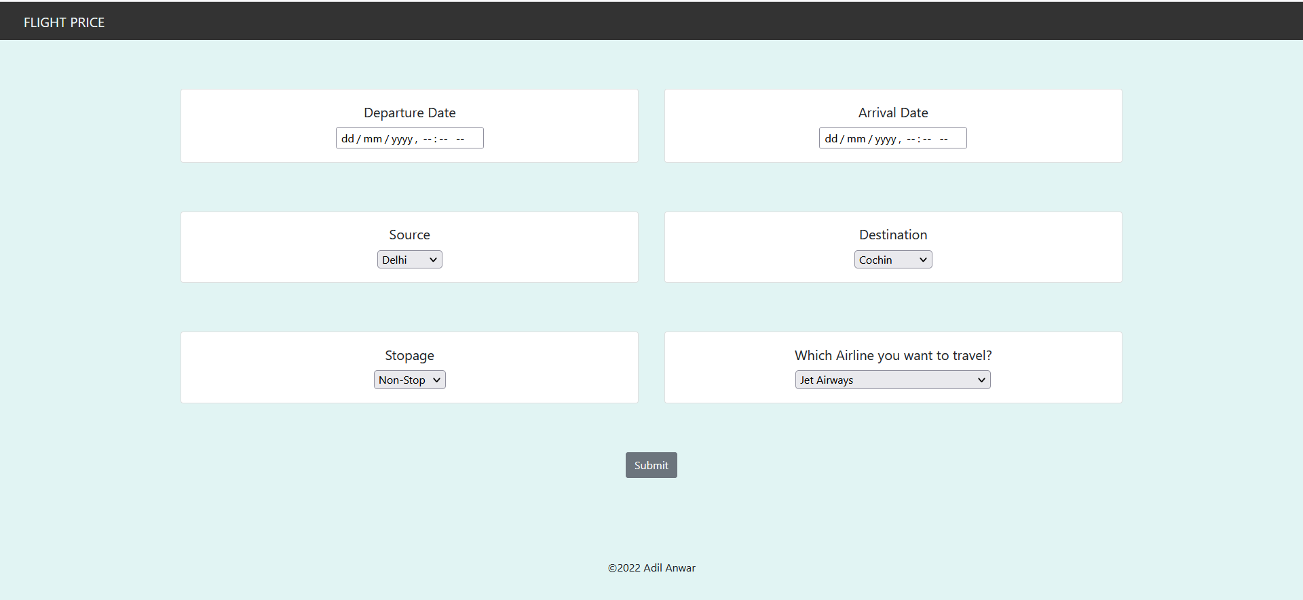

**Prediction and Result Page:**

On this page there will be form for Flight Fare to predict. User have to fill all the details and have to click on Submit button. Below is the image which shows how form will look like:

